Period | Topic | Learning objectives | Language | Practical methods | Text types | Evaluation
34 – 50  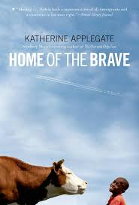   | The US | Explore and describe ways of living, ways of thinking, communication patterns and diversity in the English-speaking world.  Compare being a teenager in the United States with being a teenager in Norway.  Explore and reflect on the situation of indigenous people in the US, and other minority groups.  Recognize characteristics of American English.  Use key patterns of pronunciation in communication  Identify and use the passive voice. | The passive voice  British and American English  Pronunciation | Back-to-back exercise  Quiz  Flock reading  Poster carousel  Group relay race  Hot seat  Poem in pieces  Vocabulary bingo  Watch film clips from the election | Factual texts  Map  Song lyrics  Articles  Extracts from novels  Speeches  Poems  Book review | Writing:  - Hand in - “America the great”  Speaking:  - Present state poster  - “Quest of the week”  
 | Both sides | Choose and use different listening and speaking strategies that are suitable for the purpose.  Express and justify opinions about different topics.  Discuss topics from both sides.  Recognise and use fixed expressions with prepositions.  Differentiate between easily confused words.  Watch the documentary “På bortebane” – season 1, episode 1 (death penalty)  https://www.youtube.com/watch?v=xQLpkV3cD9Q | Linking words  Easily confused words  Fixed expressions with prepositions | Star orienteering  Glossary relay race  4 corner exercise  Oral exercise – “I would rather”  Oral relay race  Debate  Online research  Role play – ethical dilemma | Article  Debatable claim  Novel extract  Short story  Arguments | Writing:  - Tasks – documentary + conversation, argumentative paragraph  Speaking:  podcast/presentation, Quest of the week – “For and against”  
 | Parts of the novel – “Home of the brave” by Katherine Applegate | Explore the challenges and difficulties refugees face all over the world and find out what the current situation is like in today’s society. | Proverbs  Metaphors  Comparisons | Audio files  Anticipation guide  Reflection | Verse novel extracts  Factual texts  Poem | Writing:  - Tasks – “Home of the brave”
 | Parts of the novel – “The Hate U Give” by Angie Thomas | Explore the themes of prejudice, discrimination, racism, and police violence, and connect these to current and historical events. | Slang  Informal language/ expressions | Audio files  Film  Anticipation guide  Reflection | Novel extracts | Speaking:  - Group discussion

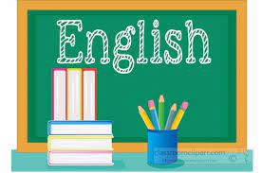
Relevance and central values: https://www.udir.no/lk20/eng01-04/om-faget/fagets-relevans-og-verdier
Interdisciplinary topics: https://www.udir.no/lk20/eng01-04/om-faget/tverrfaglige-temaer?lang=nob
Core elements: https://www.udir.no/lk20/eng01-04/om-faget/kjerneelementer
Basic skills: https://www.udir.no/lk20/eng01-04/om-faget/grunnleggende-ferdigheter

