

Stavanger kommune

OPPVEKST OG LEVEKÅR

# Johannes Læringssenter

# http://www.mot.no/wp-content/uploads/2013/10/visrespekt.pngRules and regulations regarding absence and orderliness at the Introduction Secondary School (IFSU)

We will respect one another.

We will talk to each other in a nice and polite way.

Psychological and physical bullying is not permitted at this school.

No one will borrow or take something from others without asking for permission.

Cursing is prohibited.

We raise our hand if we want to say something in class. We

listen when others talk.

It is not permitted to bring items that can harm others at school, e.g. a knife.

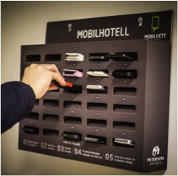Everyone is required to be on time and have their school equipment ready for class.

Cellphones must be turned off in class. Students must put their cellphones in the cellphone-hotel when entering the classroom. If a student needs to have his/her cellphone turned on during class, the student needs permission from the teacher.

Students can only use a computer when the teacher gives them permission.

It is not permitted to leave the school’s premises during school hours.



Everyone must leave their desk clean and tidy at the end of class. Everyone has the responsibility of making sure that the common area and schoolyard are tidy and clean.

It is not permitted to bring or use addictive substances, such as cigarettes, smokeless tobacco, and alcohol at school. The school will contact parents/guardians immediately if a student breaks the rule regarding addictive substances.

If a student does not follow the orderliness regulations, the student will receive a remark. If the student receives many remarks, the school will contact the student’s parents/guardians.

When a student has been absent from school, parents/guardians need to write an explanation/a note in the student’s message book.

If a student needs to be absent from class for a few hours or a whole day, the student’s parents/guardians need to write an application for the absence in the message book. If a student needs a leave of absence for more than a day, parents/guardians need to apply using a form.

Place/Date: Signature student and parent(s)/guardian(s)

…………………………… ……………………………………..

……………………………………..