MY DAY

Hello!
I am time. You can't see me, but I'm always passing by. I pass by while you walk to school. When you are sleeping and dreaming about tomorrow, I'm passing by. Your birthday? It's just me, passing by for a day! The time tells you how old you are.
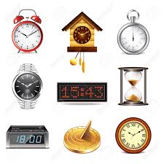
Good morning!
I'm a clock. You use me every day. You can't get enough of me!
I come in many different shapes and sizes. You invented me to tell the time precisely. And now you use me for almost everything you do!
What would happen to time if we didn't have clocks? Not much. Time continues to pass. But I'm here to help you get to school on time!

Hey there!
I'm the sun. I'm really important for measuring time, if I can say so myself. I invented time! I decide if it's winter, spring, summer or autumn, day, night, evening or morning. I'm always on time!

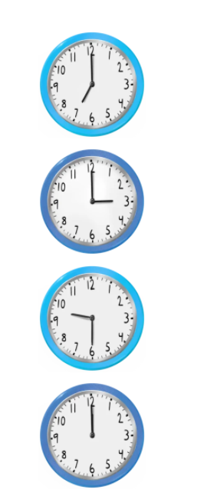
What's your routine?
Our everyday life is made up of routines. A routine is something that you do regularly. It's smart to have routines!

07:00 a.m. The alarm wakes me up. I press the snooze button.

07:12 a.m. Ok. I have to get up. Is someone yelling my name from the kitchen?

07:40 a.m. I eat breakfast: one slice of bread with jam and a glass of water.

08:05 a.m. Time to go to school. My friend is waiting for me. We go to school together.
Eksempler | Personlige pronomen engelsk | Personlige pronomen norsk
 | I | Jeg
 | You | Du
Daddy, Peter | He | Han
Mum, Sophia | She | Hun
Car, jacket, dog | It | Den/det
Tara and I | We | Vi
Tom and you | You | Dere
Tara and Liza, mum and dad, snakes | They | De

08:30 a.m. School starts. I am ready!
16:15 p.m. Time for homework.

GLOSEØVINGSOPPGAVER – UKE 43
 | English |  | Norwegian
 | Time |  | Tid
 | Passing by |  | Passerer
 | While |  | Mens
 | Tells |  | Dro, reiste
 | Enough |  | Nok
 | Tell the time precisely |  | Å si hva klokken er
 | Continues |  | Fortsetter
 | Measuring |  | Måler
 | Decide |  | Bestemme
 | Regularly |  | Regelmessig
Skriv inn glosene 3 ganger i skjemaet på engelsk
Time
Passing by
While
Tells
Enough
Tell the time precisely
Continues
Measuring
Decide
Regularly
Oppgave 1) WORDSEARCH
Nedenfor finner du ukens gloser i mylderet. Denne gangen finner du glosene både vannrett og loddrett. Lykke til
NB! Glosen “Tell the time precisely” og “Passing by” finner dere slik: “tellthetimeprecisely” og “passingby”.
V | B | T | C | L | W | H | Y | N | E | C | A | D | R | H | L | O | P | L | E
W | H | I | L | E | G | A | S | X | R | E | G | U | L | A | R | L | Y | D | I
U | S | M | B | L | M | L | S | X | Z | B | Y | J | P | B | I | L | A | V | D
D | F | E | B | G | F | I | D | I | T | O | P | B | T | E | L | L | S | B | T
E | A | P | A | S | S | I | N | G | B | Y | W | S | A | B | K | K | N | W | Y
C | S | S | R | W | O | J | L | E | B | C | O | N | T | I | N | U | E | S | h
I | E | L | L | T | H | E | T | I | M | E | P | R | E | C | I | S | E | L | Y
D | B | R | H | L | O | P | L | E | Y | T | E | A | E | N | O | U | G | H | H
E | E | P | U | L | G | D | D | I | U | F | E | I | C | P | B | I | L | A | W
U | P | B | I | L | A | T | C | W | M | E | A | S | U | R | I | N | G | K | Y
Skriv ned ordene etter hvert som du finner dem:
English | Norwegian

Oppgave 2) Unscramble the words (her er bokstavene snudd om. Finn riktig ord og skriv det på engelsk og norsk):
Scrambled word | Unscrambled word | In Norwegian
ILEWH
UGHENO
NUESCONTI
METI
LARLYREGU
ISELYPRECMETIEHTLLET
YBINGPASS
URINGMEAS
CIDEDE
METI
LLSTE

Grammar tasks (setningene skal skrives i skriveboken):
- Erstatt med et personlig pronomen: (Eks: Sophia = she)
  - My father and I = __________
  - Grandmother = __________
  - My brother and I = __________
  - Uncle and aunt = __________
  - Monkey = __________
  - Monkeys = __________
  - Simon and Sophia = __________
  - Liza = __________

What time is it?

Mark the clock that matches the sentence (sett kryss over klokken som passer til setningen).
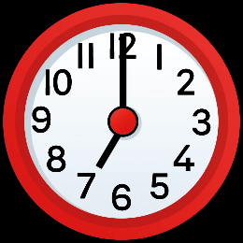
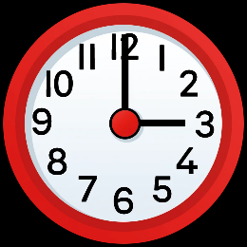
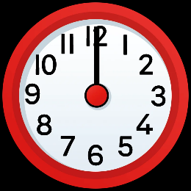

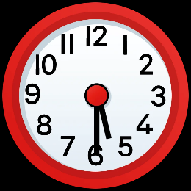
At noon, I drink a banana smoothie with my lunch.
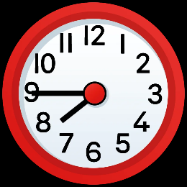

School finishes at three o’clock.

My swimming lesson starts at half past five.

